NAME | <*NAME1*> | DATE | <*DATE*>
 |  | AGE | <Age>
REF. BY | DR.<*Consultant/Gp1*> | SEX | <Sex>

X-RAY CHEST (PA. VIEW).

Both visualized lung fields are clear.

No mediastinal abnormality is visible.

The peripheral pulmonary vasculature is normal.

Both hilum are normal in size, position & density.

Both Cardiophrenic & Costophrenic angles are clear.

Both domes of the diaphragms are normal in position.

Cardiac shadow appears normal.

Ribs appear normal.

IMPRESSION : NO SIGNIFICANT ABNORMALITY DETECTED.

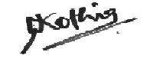

DR. NIKUNJ KOTHIA
CONS. RADIOLOGIST

